*You are the voice of the large agricultural supply companies such as Cargill, Monsanto, BASF, Bayer, DuPont, Syngenta, and Dow Chemical. Your job is to attract consumers to your product. You also lobby governments both foreign and our own, to secure legislation and policies to use your products exclusively in certain markets and influence agricultural and environmental policies.*

**Background Information:**

* There is a huge financial incentive to keep the agricultural practices around the world as they are now until the large companies can bargain individually with developing nations to set agricultural policy and gain exclusive rights to seed sales.
* Your company has enormous amounts of resources available to influence public policy, conduct global education campaigns, buy large chunks of land, and other programs to build food export infrastructure in developing nations.
* Your company is working with other large agriculture businesses to research and develop transgenic seeds that are more drought, disease, and pest resistant.
* Agricultural production is a risky business and poses a number of challenges to economic success because production requires extensive amount of land, involves long periods of time, is highly unpredictable due to such things as weather, pests, and the perishable nature of food. Selling farmers the transgenic seeds modified to produce consistently reduces some of the hazards of farming, allowing farmers to make more profit from more uniform, consistent crop yields.
* Our seeds are fully patent-protected so farmers must, by law, buy new seeds every year, generating revenue for your company.
* The higher yields with these seeds allow farmers to have a higher degree of confidence in science and technologic innovations that we can offer them. They will be more likely to enter the Agricultural Treadmill (see figure) and be willing to adopt more of our product.
* As farmers enter the Agricultural Treadmill, it allows our company to grow and to consolidate a larger number of smaller companies under us, lessening the competition, and increasing our global success.
* The top 4 pesticide firms control 59% of the global market and the top 4 seed firms control 56% of the global seed market
* Pharmaceutical and chemical companies merge to become “life science” companies, enhancing product lines, markets, and lobbying power.

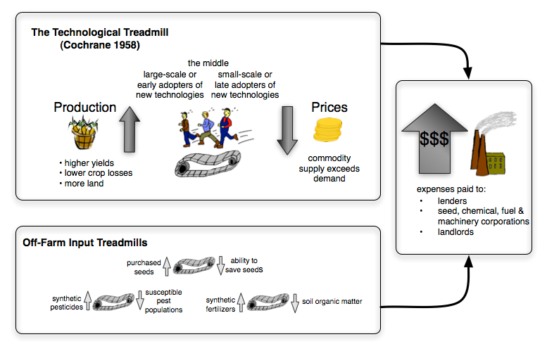

<http://www.ecowalkthetalk.com/blog/wp-content/uploads/2011/09/The-Technological-Treadmill.gif>